**Signing Up for ArcGIS Online**

**Pre-Requisite for Addressing Deep Dive**

**Objective**

ArcGIS Online is an online, cloud-based web geographic Information system (GIS) service. Using ArcGIS Online, you can make web maps, analyze data, and share your maps and analysis with others. The basic account, which allows you to do web mapping, is available at no cost. This lesson walks you through the process of establishing your ArcGIS Online account and making your first map.

**Note on Use of Browsers with ArcGIS Online**

ArcGIS Online is supposed to work with the following browsers (Chrome, Edge, Firefox, Internet Explorer 11 (Compatibility View is not supported) and Safari). That said, there have been issues with accessing data from different browsers. Exercises can be attempted with any browser, but you may have the best success with Firefox.

**Establishing your ArcGIS Online Account**

To start the process of setting up your ArcGIS Online account, type “https://developers.arcgis.com/sign-up” in your web browser. You will be taken to the ArcGIS Online Home page (Note: you may see something different than the image below.) Fill out your First name, Last Name, Email, and click the **Send Confirmation Email** button.

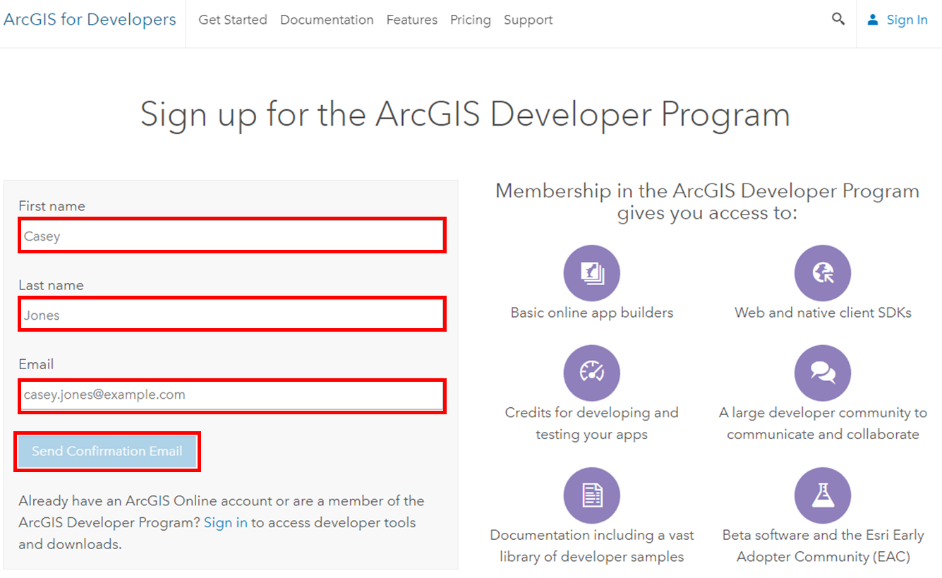

Esri will send you a confirmation email. You will see the following message.

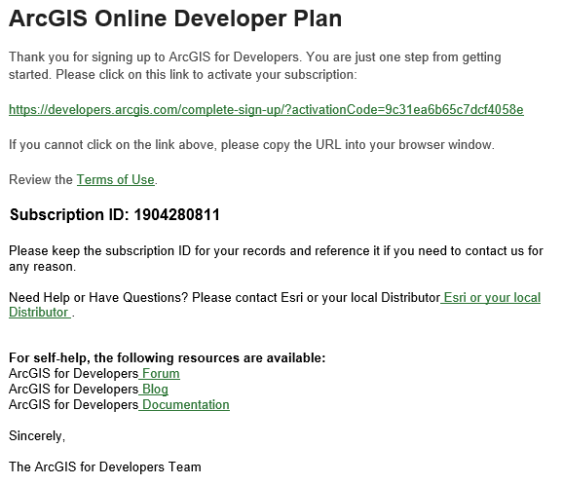

Check your email for your confirmation. Your email should contain link to activate your subscription. Click on the link to continue the process.

Click on the URL at the top to activate your account. Next you will be directed to a form to complete to create your account. Fill out the requested information, click on the **Checkbox** to accept and agree to the Terms of Use, and then Click on the **Create Developer Account** button.

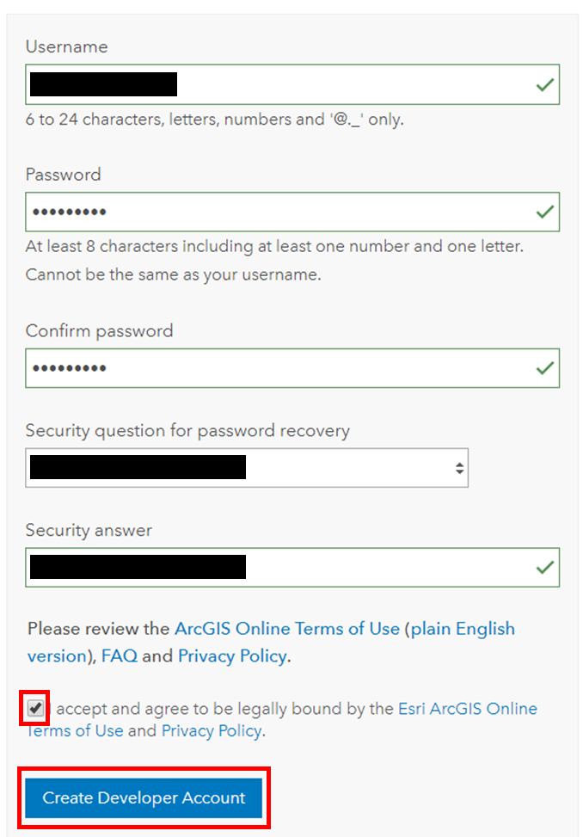

You will now be taken to the ArcGIS for Developers Dashboard.

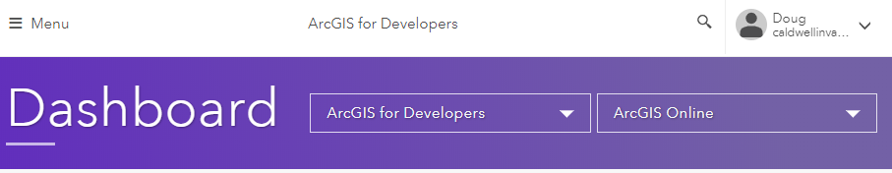

**Signing in to ArcGIS Online**

To sign in to your ArcGIS Online account, open a new browser tab and type <https://www.arcgis.com/home/signin.html> in the URL window to sign in. Enter your *Username* and *Password* and click the **SIGN IN** button.

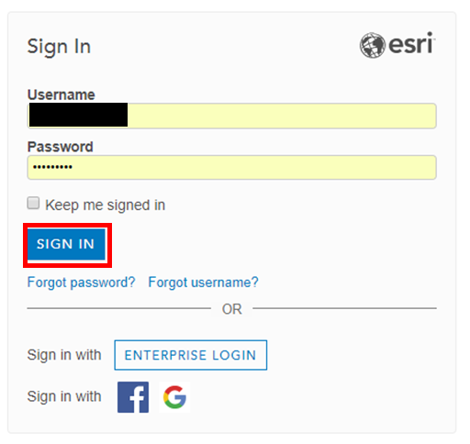

This will take you to your ArcGIS Online **Organization** section.

You will be taken to the Organization page of your ArcGIS Online account. Click on **Map** to create your first map.

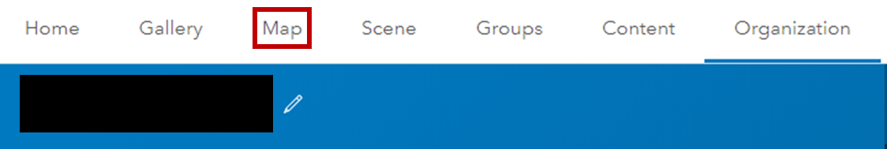

Congratulations! You have made your first map!!

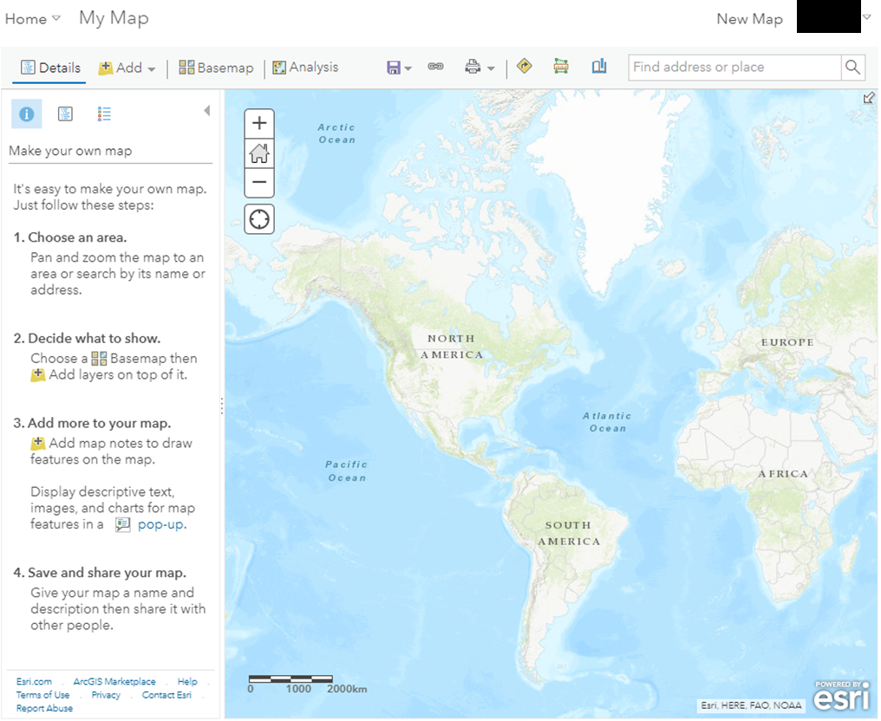

Type “Charlottesville, VA, us” in the box that says *Find Address or Place* and then click on **Charlottesville, VA, USA**.

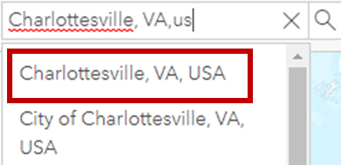

You will now see your map centered on Charlottesville.

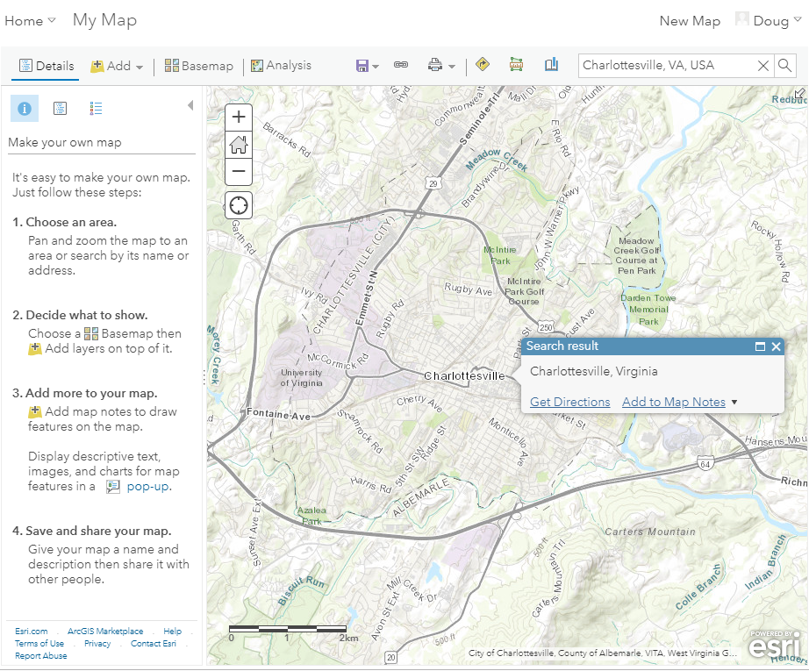

For the lessons that follow, you will repeat the process of signing in and creating a map at the start of each exercise.

You are now ready to learn the basics of navigating the ArcGIS Online and making maps. The best way to do this is to work through the tutorial

**Get Started with ArcGIS Online**  
Create and share an evacuation map to prepare for an incoming hurricane. 45 minutes

<https://learn.arcgis.com/en/projects/get-started-with-arcgis-online/>

This tutorial will take about 45 minutes, but will give you everything you need to know about ArcGIS Online for the Addressing Deep Dive.

**Contact Information**

If you have any issues or would like to submit corrections or suggestions, please contact me at …

Doug Caldwell ([caldwellinva@verizon.net](mailto:caldwellinva@verizon.net))

February 17, 2019